**Step 1: Log in to the Azure Portal**

⦁ Open your web browser and go to the [Azure Portal](https://portal.azure.com/)

⦁ Log in with your Azure credentials.

**Step 2: To create a Storage**

⦁ Choose “**Storage Accounts (Classic)**” from the column in the page after heading.

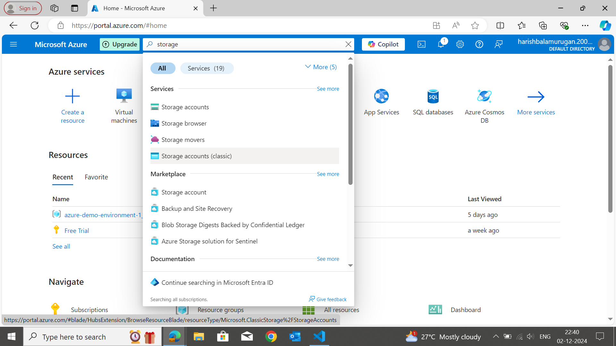

**Step 3: Configure Basic Settings**

* **Subscription:** Select the subscription if you’re a free trial user select Free Trial.
* **Resource Group:** Choose an existing resource group or click "Create new" to create a new one.
* **Storage Name:** Enter a name for your Storage (e.g., "storageazuredemo1") only numeric and lowercase letters allowed.
* **Region:** Select the Azure region where you want to create a storage. Select nearby of your country like Asia Pacific South India.
* **Performance:** In the performance option, choose “Azure Blob Storage”.
* **Redundancy:** Select Locally-redundant storage (LRS).

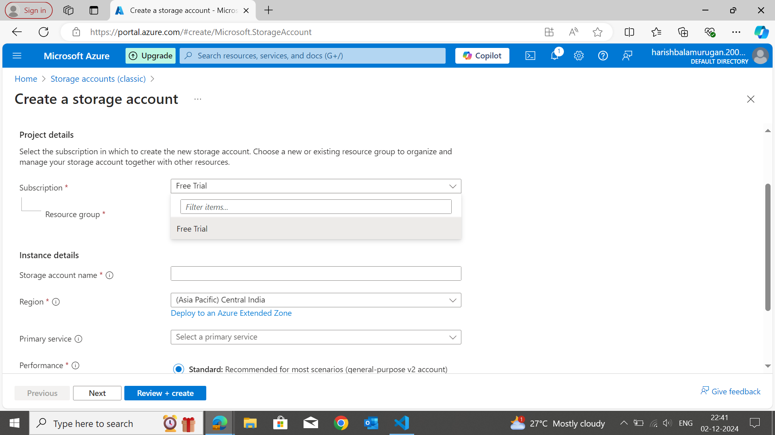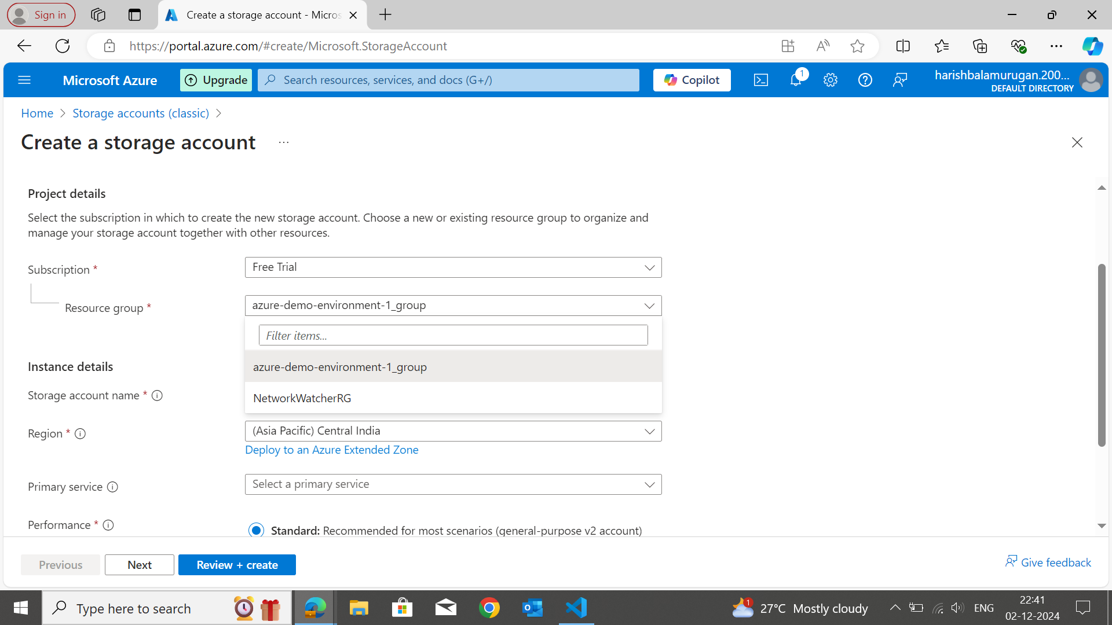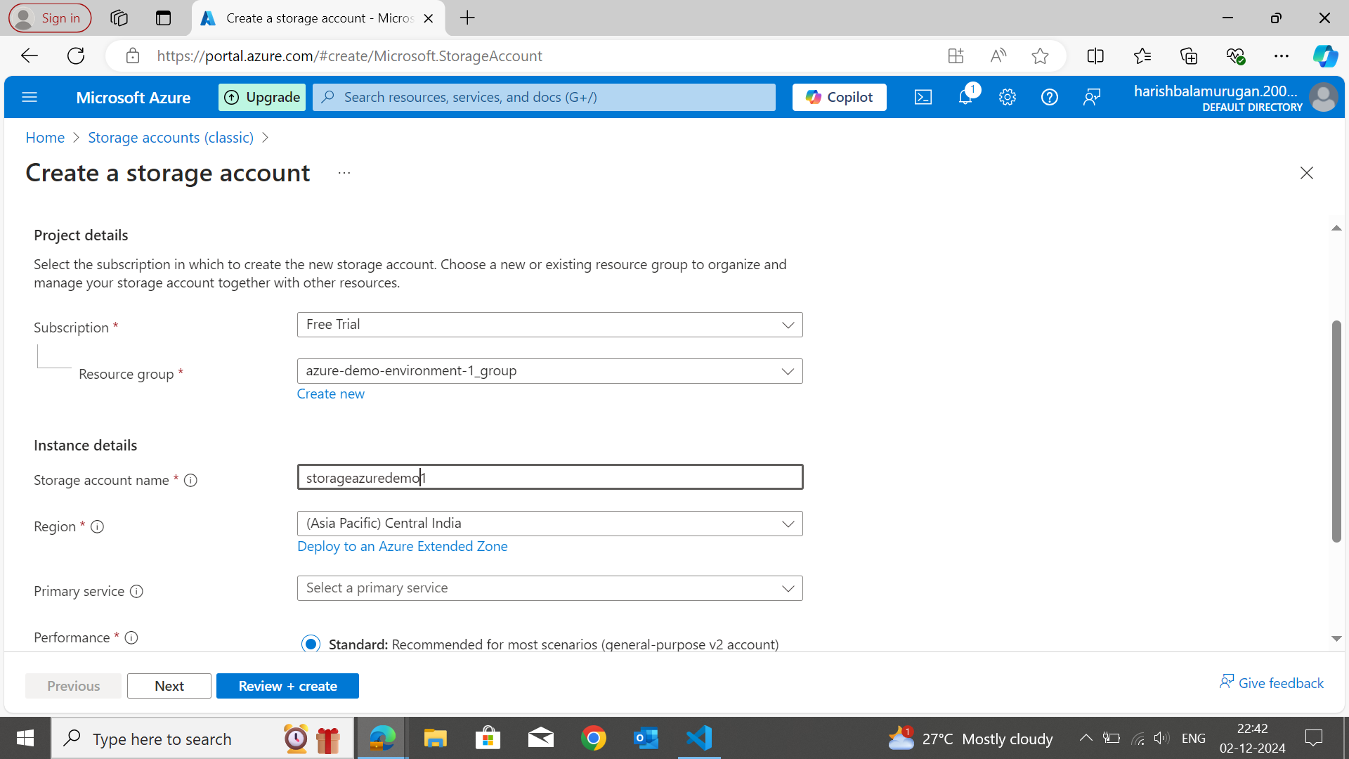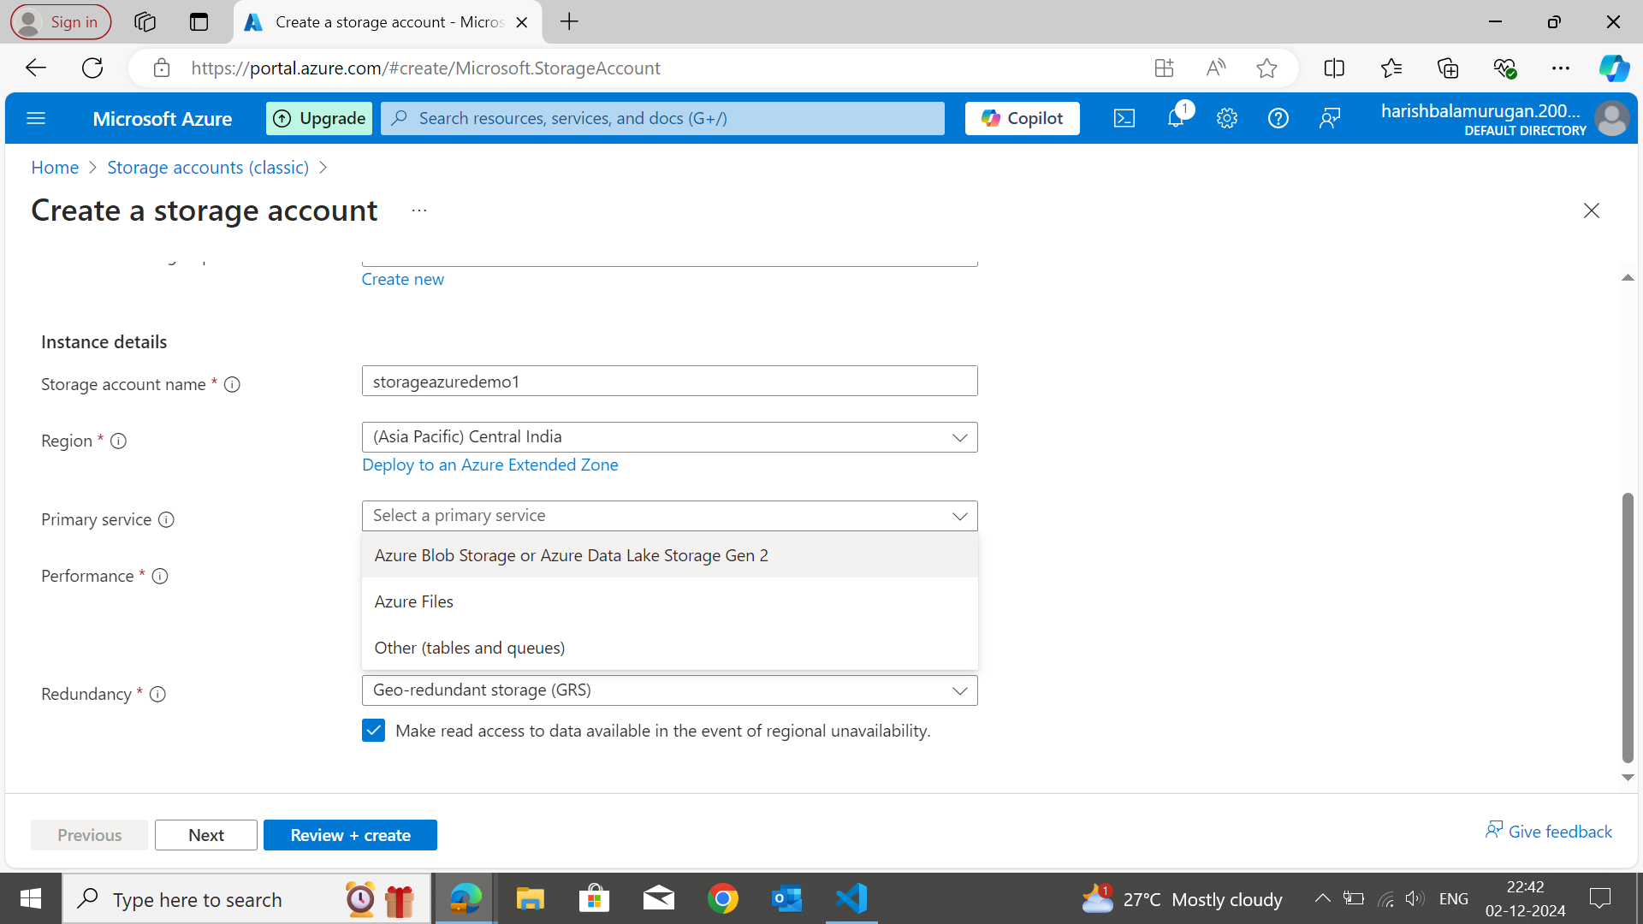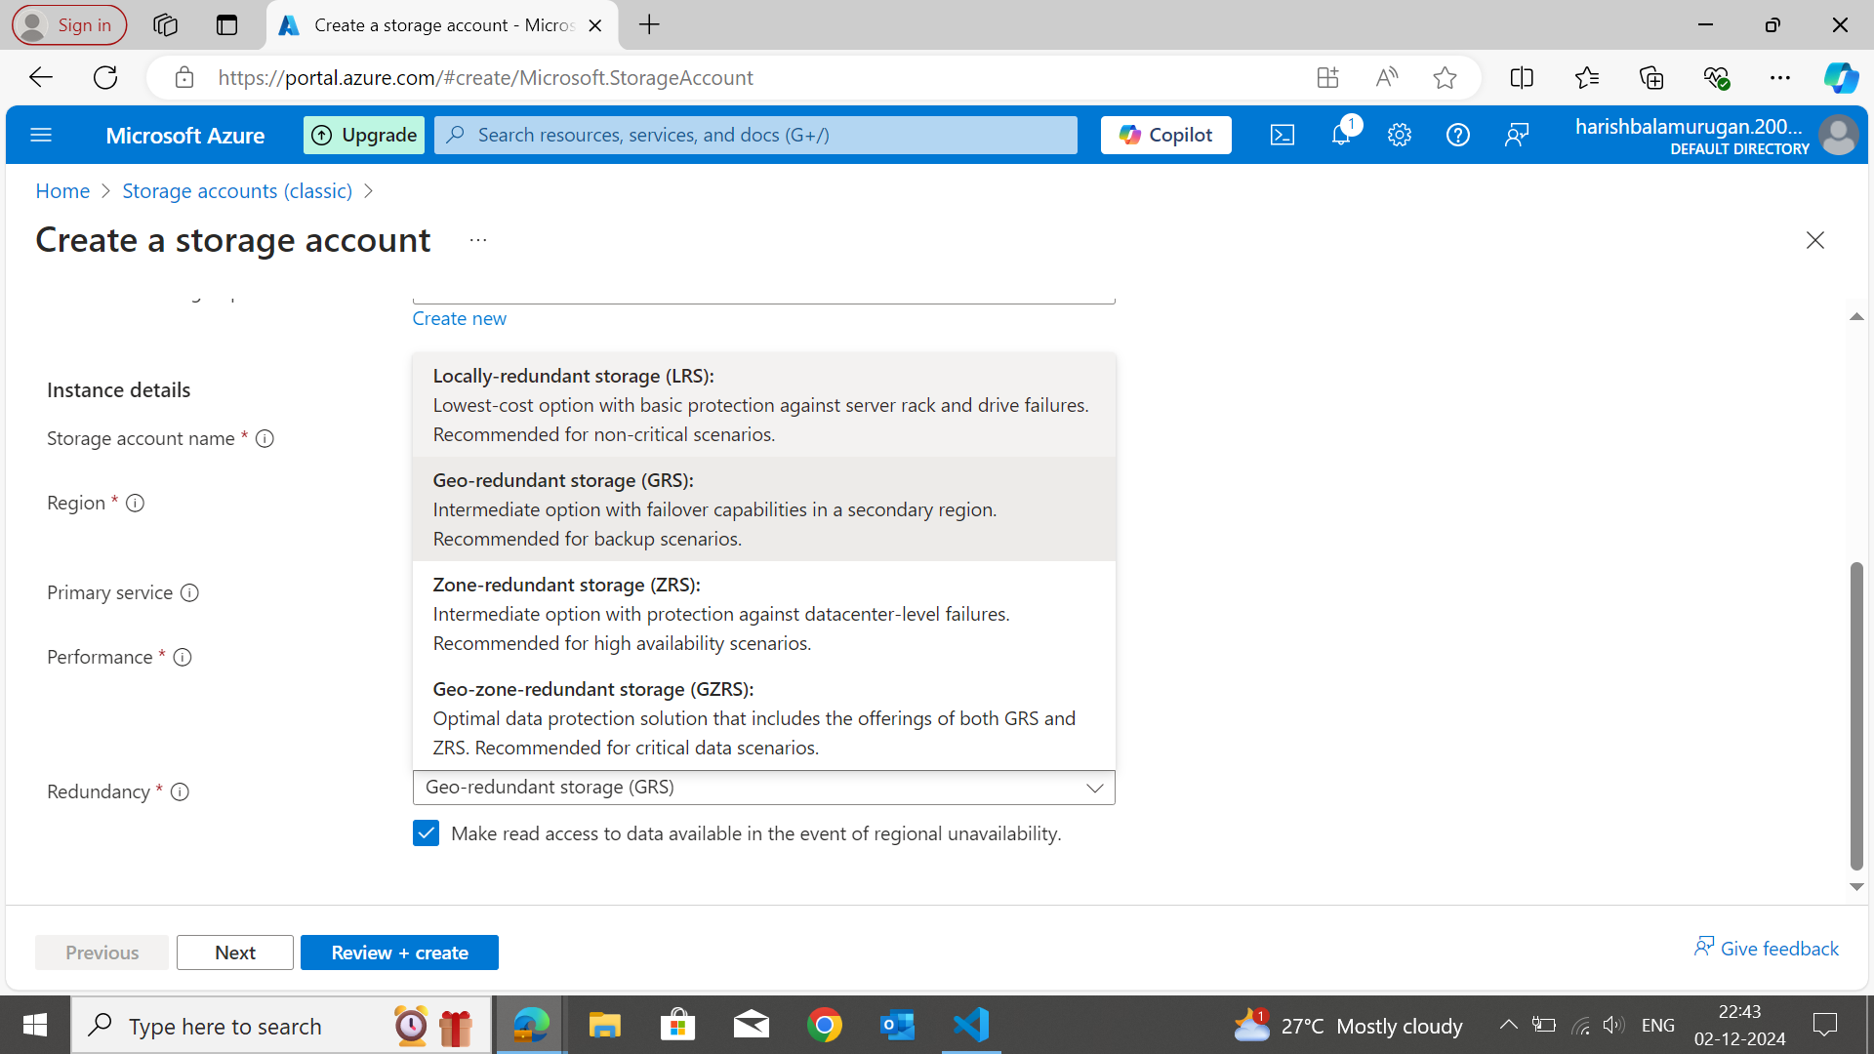

**Step 4: Review and Create**

⦁ Click the "Review + create" button.

⦁ Azure will validate the configuration. If everything is correct, you’ll see a green check mark and you can also see your basic requirements.

⦁ Review the settings and click "**Create**" to start the server deployment.

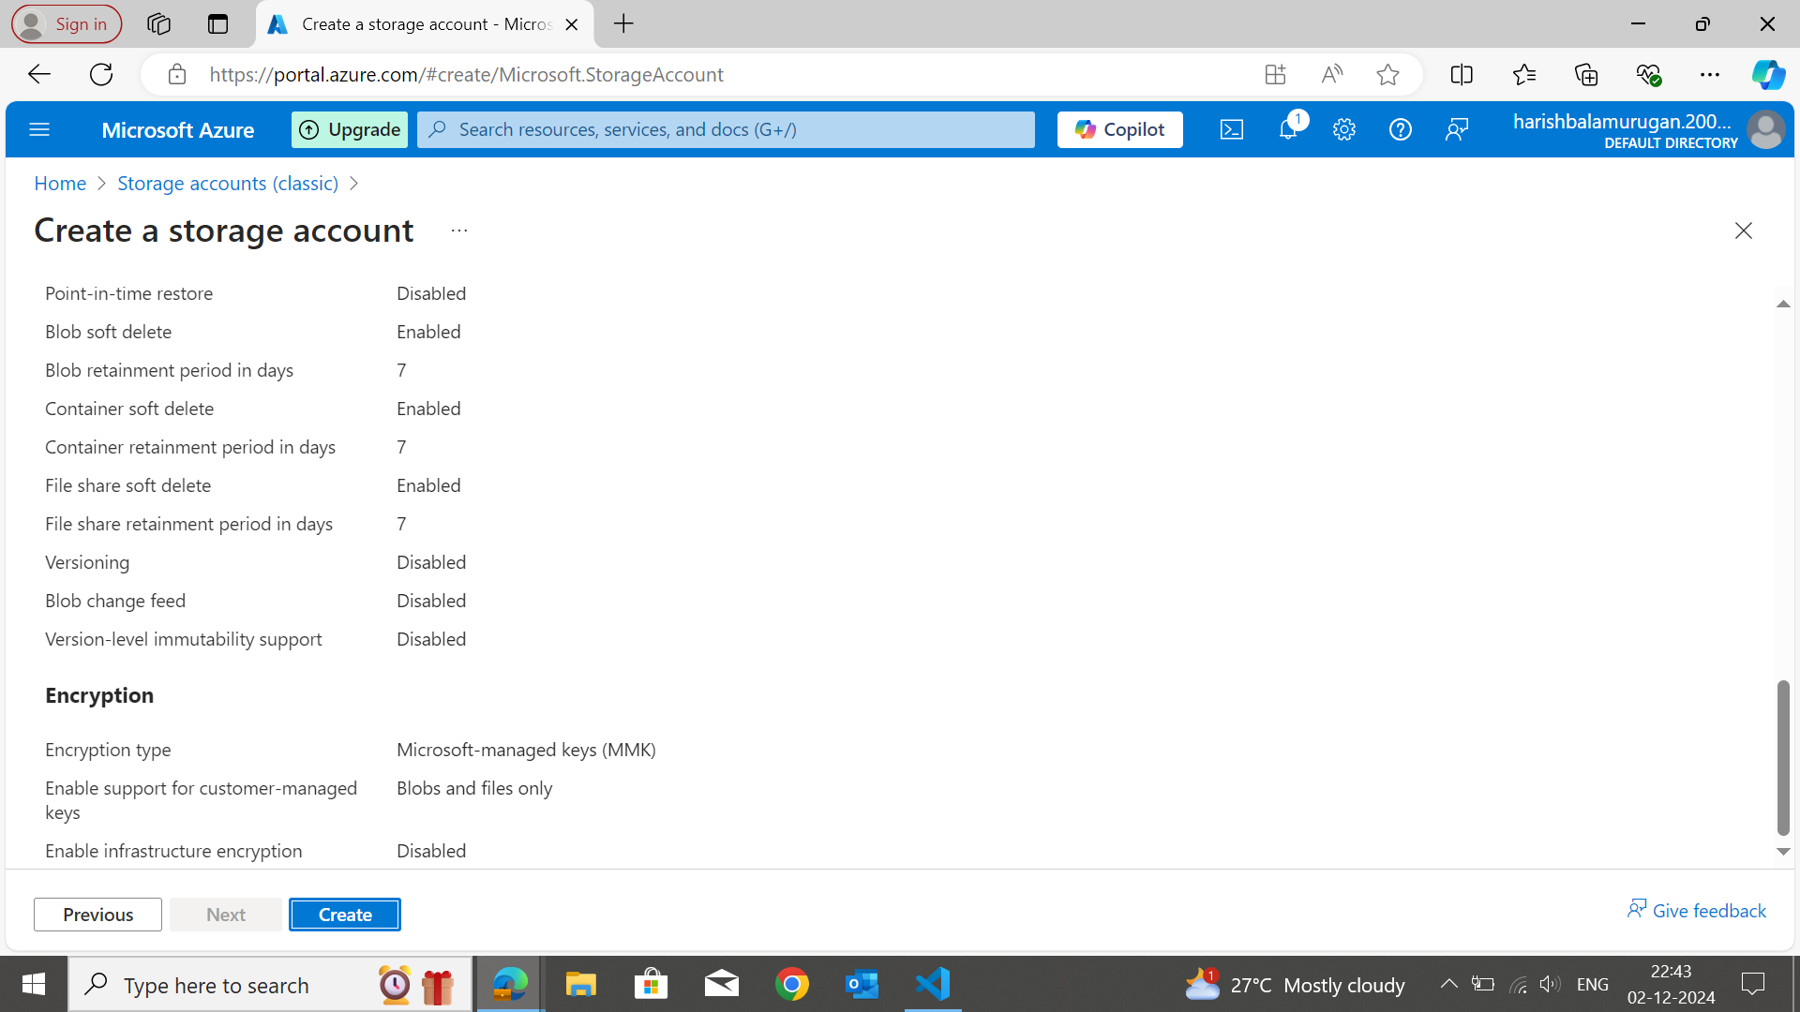

**Step 5: Deployment and Access**

⦁ Azure will begin the deployment, and you'll see the status as “Deployment in Progress”.

⦁ Once the storage is created, you will see " Your deployment is complete " and click the Go to resource to review and upload your projects.

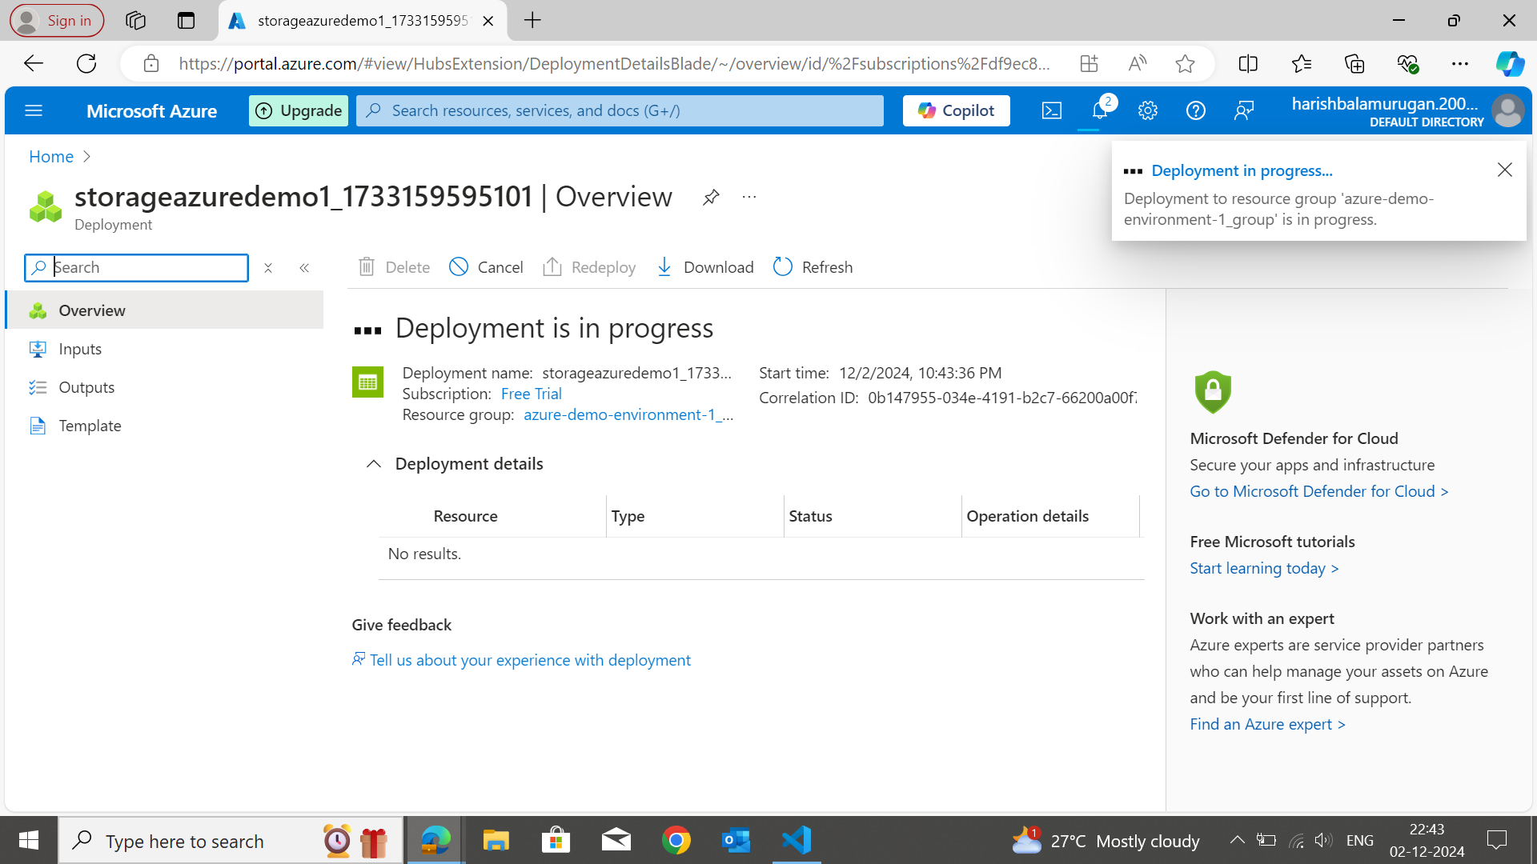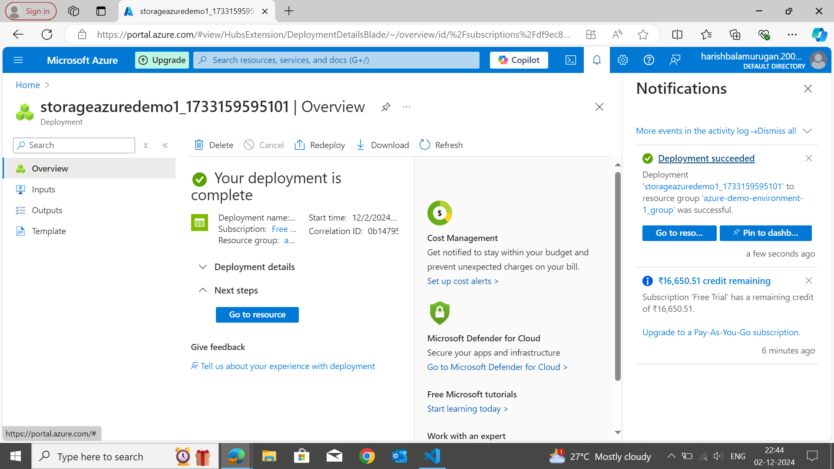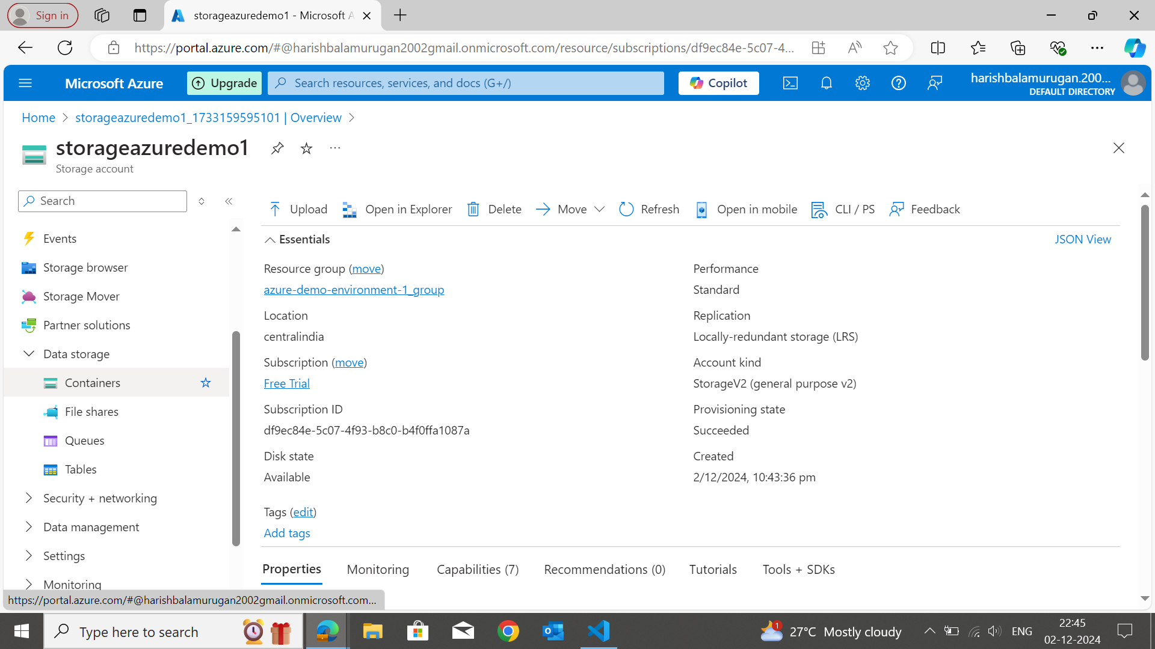

**Step 6: Create a Container and Upload any file or folder.**

Click create Container and upload a folder For Ex: - I have uploaded mine Java Console Application source code.

